**PIZZA SALES SQL QUERIES**

1. **KPIS**
2. **Total Revenue**

SELECT SUM(total_price) AS Total_Revenue from pizza_sales;

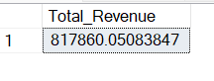

1. **Average Order Value**

SELECT SUM(total_price) / COUNT(DISTINCT order_id) as avg_order_Value from pizza_sales;

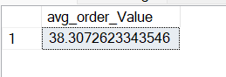

1. **Total Pizzas sold**

SELECT SUM(quantity) as Total_pizza_sold FROM pizza_sales

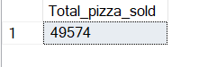

1. **Total Orders**

SELECT COUNT(DISTINCT order_id) AS Total_Orders FROM pizza_sales

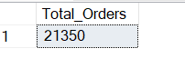

1. **Average Pizzas Per Order**

SELECT CAST(CAST(SUM(quantity) AS DECIMAL (10,2))

/ CAST(COUNT(DISTINCT order_id) AS DECIMAL (10,2)) AS DECIMAL(10,2)) from pizza_sales

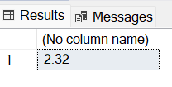

1. **Daily Trend for Total Orders**

SELECT DATENAME(DW, order_date) AS order_day, COUNT(DISTINCT order_id) AS total_orders

FROM pizza_sales

GROUP BY DATENAME(DW, order_date)

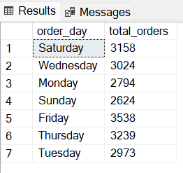

**C. Monthly Trend for Orders**

SELECT DATENAME(MONTH, order_date) as Month_Name, COUNT(DISTINCT order_id)

as Total_Orders

from pizza_sales

GROUP BY DATENAME(MONTH, order_date)

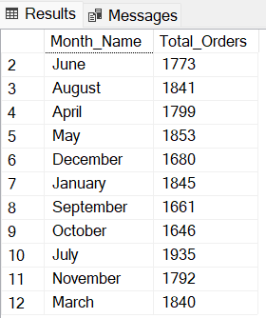

**D. % of Sales by Pizza Category**

SELECT pizza_category, sum(total_price) * 100 / (SELECT sum(total_price) from pizza_sales)

from pizza_sales AS Total_sales

group by pizza_category

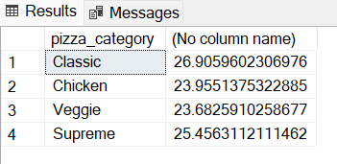

**E. % of Sales by Pizza Size**

SELECT pizza_size, cast(sum(total_price) AS DECIMAL(10, 2)) as total_revenue,

cast(sum(total_price) * 100 / (select sum(total_price) from pizza_sales)

as decimal(10, 2)) as PCT

FROM pizza_sales

group by pizza_size

order by pizza_size

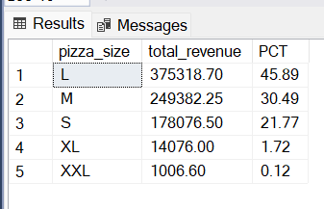

**F. Total Pizzas Sold by Pizza Category**

SELECT pizza_size, cast(sum(total_price) AS DECIMAL(10, 2)) as total_revenue,

cast(sum(total_price) * 100 / (select sum(total_price) from pizza_sales)

as decimal(10, 2)) as PCT

FROM pizza_sales

group by pizza_size

order by pizza_size

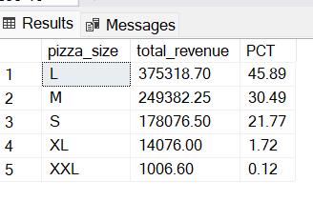

**F. Total Pizzas Sold by Pizza Category**

SELECT pizza_category, sum(quantity) as Total_Quantity_Sold

from pizza_sales

where month(order_date) = 2

group by pizza_category

order by Total_Quantity_Sold DESC

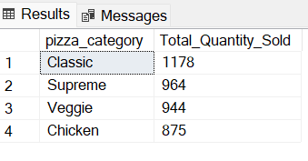

**G. Top 5 Pizzas by Revenue**

select top 5 pizza_name, sum(total_price) as Revenue from pizza_sales

group by pizza_name

order by Revenue DESC

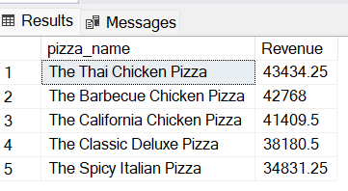

**H. Bottom 5 Pizzas by Revenue**

select top 5 pizza_name, sum(total_price) as Revenue from pizza_sales

group by pizza_name

order by Revenue ASC

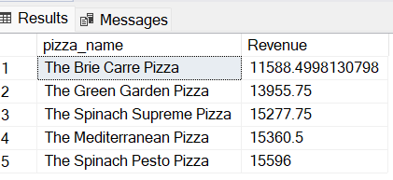

**I. Top 5 Pizzas by Quantity**

select top 5 pizza_name, sum(quantity) as QTY from pizza_sales

group by pizza_name

order by QTY

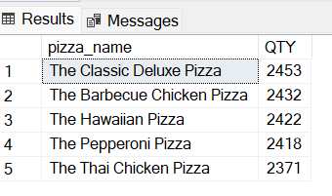

**J. Bottom 5 Pizzas by Quantity**

select top 5 pizza_name, sum(quantity) as QTY from pizza_sales

group by pizza_name

order by QTY

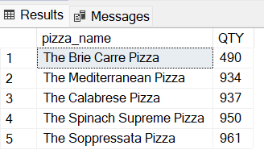

**K. Top 5 Pizzas by Total Orders**

select top 5 pizza_name, count(distinct(order_id)) as Total_orders

from pizza_sales

group by pizza_name

order by Total_orders desc

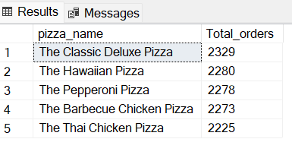

**L. Bottom 5 Pizzas by Total Orders**

select top 5 pizza_name, count(distinct(order_id)) as Total_orders

from pizza_sales

group by pizza_name

order by Total_orders asc

